ANALYSIS, RESULTS AND INTERPRETATIONS
Data Visualization
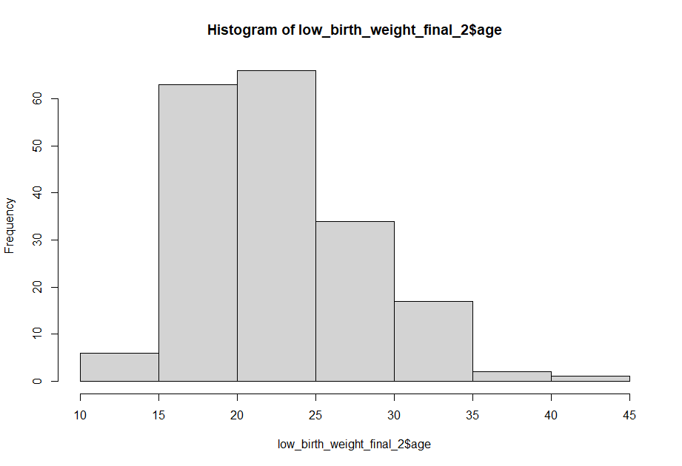
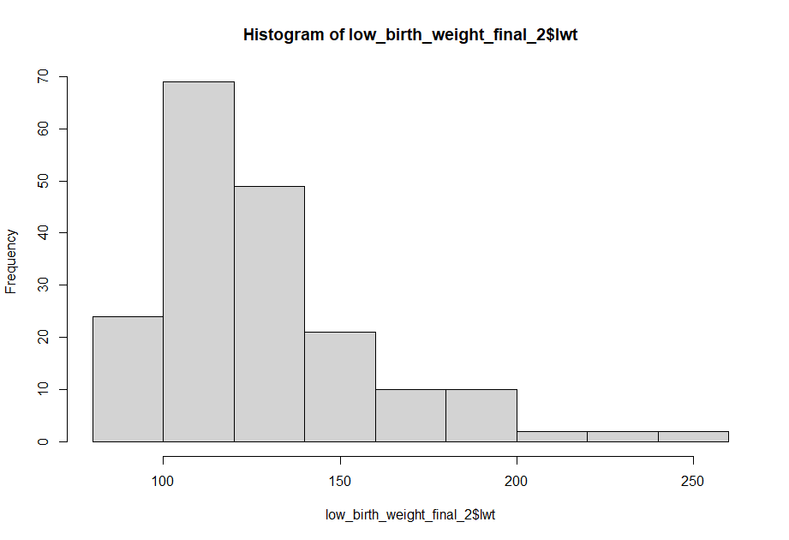
Bar chart of low_birth_weight_final_2$race
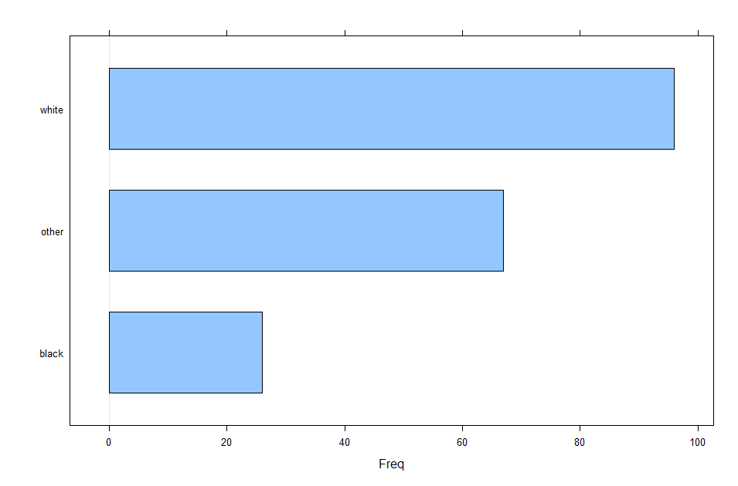
Descriptive Statistics
Mother’s age in years
Minimum age – 14 years
1ST quartile- 19
Median – 23
Mean - 23.24
3RD Quartile - 26
Maximum age – 45
Variance – 28.08
Standard deviation – 5.30
Mother’s weight in pounds at last menstrual period(lwt)
Minimum -80
1st quartile – 110
Median – 121
Mean – 129.7
3rd quartile – 140
Maximum – 250
Variance - 939.25
Standard deviation – 30.65
Hypothesis Testing
: Risk factors associated with low infant birth weight
Factor | Overall, N = 189¹ | Low birth weight |  | p-value²
Factor | Overall, N = 189¹ | Yes, N = 59¹ | No, N = 130¹ | p-value²
mother's age in years |  |  |  | 0.2
below 25yrs | 135 (100%) | 46 (34%) | 89 (66%)
above 25yrs | 54 (100%) | 13 (24%) | 41 (76%)
mother's weight in pounds |  |  |  | 0.2
below 160 pounds | 163 (100%) | 54 (33%) | 109 (67%)
above 160 pounds | 26 (100%) | 5 (19%) | 21 (81%)
race |  |  |  | 0.082
black | 26 (100%) | 11 (42%) | 15 (58%)
other | 67 (100%) | 25 (37%) | 42 (63%)
white | 96 (100%) | 23 (24%) | 73 (76%)
smoke |  |  |  | 0.026
smoke | 74 (100%) | 30 (41%) | 44 (59%)
don't smoke | 115 (100%) | 29 (25%) | 86 (75%)
history of hypertension | 12 (100%) | 7 (58%) | 5 (42%) | 0.052
uterine irritability | 28 (100%) | 14 (50%) | 14 (50%) | 0.020
visits |  |  |  | 0.13
visits during the trimester | 89 (100%) | 23 (26%) | 66 (74%)
no visits during the trimester | 100 (100%) | 36 (36%) | 64 (64%)
number of previous premature labours |  |  |  | <0.001
previous premature labours | 30 (100%) | 18 (60%) | 12 (40%)
no previous premature labours | 159 (100%) | 41 (26%) | 118 (74%)
birth weight in grams |  |  |  | <0.001
below 2500 grams | 96 (100%) | 58 (60%) | 38 (40%)
above 2500 grams | 93 (100%) | 1 (1.1%) | 92 (99%)
¹ n (%)
² Pearson’s Chi-squared test; Fisher’s exact test

For mother’s age in years those who had low birth weight and were below 25 years were (34 %) while the ones who didn’t were (66%.) The ones above 25 years, (24%) had low birth weight while (76%) didn’t. The (p value = 0.2) was statistically insignificant. In mother’s weight in pounds, under low birth weight, the ones who were below 160 pounds, (33%) chose yes and (67%) chose no while the ones above 160 pounds, (19%) chose yes and (81%) chose no. The (p value= 0.2) was statistically insignificant. Under race, black people who chose yes were (42%) while those who said no were (58%). As for white people, (24%) chose yes while (76%) chose no. For other race, (37%) chose yes while (63%) said no, under low birth weight. The (p value=0.082) was statistically insignificant. As for smoking, those who smoke, (41%) said yes under low birth weight and (59%) said no. Those that don’t smoke, (25%) said yes and (75%) said no for low birth weight. The (p value=0.026) was statistically significant thus showing an association of smoke and low birth weight. For history of hypertension, under low birth weight as a response, (58%) said yes while (42%) said no. The (p value=0.052) was statistically insignificant. In uterine irritability ,(50%) chose yes while (50%) chose no. The (p value=0.020) was statistically significant hence showing an association with low birth weight. As for visits, visits during trimester had (26%) for yes and (74%) for no while no visits during the trimester, those who said yes were (36%) and no were (64%). The (p value=0.13) was statistically insignificant. In number of previous premature labours ,previous premature labours(60%) were yes and (40%) were no while no previous premature labours, (26%) were yes and (74%) were no. The (p value=<0.001) was statistically significant thus showing association with low birth weight. In birth weight in grams, those under below 2500 grams, (60%) were yes and (40%) were no in low birth weight as a response while above 2500 grams, (1.1%) were yes and (99%) were no in low birth weight. The (p value=<0.001) was statistically significant thus showing association with low birth weight.

Exploratory bivariate analysis for risk factors of low birth weight
Two way anova of age and lwt
H0: there is no significant interaction between the independent variables
H1: there is significant interaction between the two independent variables
(p value=0.7636). Since p-value>0.05, therefore we fail to reject the null hypothesis and conclude that there is no significant interaction between the two independent variables.
Two way anova of age and bwt
H0: there is no significant interaction between the independent variables
H1: there is significant interaction between the two independent variables (p value=0.723)
Since p-value>0.05, therefore we fail to reject the null hypothesis and conclude that there is no significant interaction between the two independent variables.
Chi-square test
Low & smoke
Pearson's Chi-squared test

data: tbl2
X-squared = 4.9237, df = 1, p-value = 0.02649

H0: there is no association between the independent variables
H1: there is association between the independent variables
On tbl2 the p value is 0.026<0.05 which means we reject the null hypothesis, therefore there is association between the independent variables low and smoke

Low & ptl
Pearson's Chi-squared test

data: tbl3
X-squared = 13.759, df = 1, p-value = 0.0002078

H0: there is no association between the independent variables
H1: there is association between the independent variables
On tbl3 the p value is 0<0.05 which means we reject the null hypothesis, therefore there is association between the independent variables low and ptl.
Correlation test
Low_ and agecut

Pearson's product-moment correlation

data: low_birth_weight_final_2$agecut and low_birth_weight_final_2$low_
t = 1.3396, df = 187, p-value = 0.182
alternative hypothesis: true correlation is not equal to 0
95 percent confidence interval:
-0.04587731 0.23692483
sample estimates:
cor
0.09749135

H0: correlation is not equal to zero
H1: correlation is equal to zero
Since p value >0.05 we fail to reject H0 thus showing that the correlation is not equal to zero. This shows that there is a relationship between the two variables and a weak positive correlation.

Low_ and lwt_
Pearson's product-moment correlation

data: low_birth_weight_final_2$lwt_ and low_birth_weight_final_2$low_
t = 1.4203, df = 187, p-value = 0.1572
alternative hypothesis: true correlation is not equal to 0
95 percent confidence interval:
-0.0400115 0.2424638
sample estimates:
cor
0.1033088

H0: correlation is not equal to zero
H1: correlation is equal to zero
Since p value>0.05 we fail to reject H0 thus showing that the correlation is not equal to zero. This shows that there is a relationship between the two variables and a weak positive correlation.

Multivariate logistic regression model of risk factors of low birth weight
Characteristic | OR¹ | 95% CI¹ | p-value
(Intercept) | 0.09 | 0.02, 0.38 | 0.003
smoke
smoke | — | —
don't smoke | 1.30 | 0.55, 3.08 | 0.5
uterine irritability
Yes | — | —
No | 1.56 | 0.54, 4.76 | 0.4
number of previous premature labours
previous premature labours | — | —
no previous premature labours | 5.88 | 1.73, 27.5 | 0.010
birth weight in grams
below 2500 grams | — | —
above 2500 grams | 0.01 | 0.00, 0.03 | <0.001
¹ OR = Odds Ratio, CI = Confidence Interval

From the results, above those who don’t smoke are 1.30 more likely to have low infant birth weight as compared to those who smoke (OR 1.30, CI. 0.55,3.08, p value=0.5). Those who said no in uterine irritability were 1.56 more likely to have low infant birth weight as compared to those who said yes (OR,1.56, CI, 0.54,4.76, p value=0.4). Those with no previous premature labours were 5.88 more likely to have low infant birth weight as compared to previous premature labours(OR 5.88, CI,1.73,27.5 p value=0.010). In birth weight, those who were above 2500 grams were 0.01 less likely to have low infant birth weight as compared to those who were below 2500 grams (OR 0.01, CI, 0.00,0.03 p value=<0.001)

